Gasser Ahmed

[gasser18@vt.edu](mailto:gasser18@vt.edu)

ECE 5484, Homework 2

1. Construct a truth table for the following:

F = (x + y)(x’ + z’)(y’ + z’)

=(x+y) z’

|  |  |  |  |  |  |
| --- | --- | --- | --- | --- | --- |
| x | y | z | x+y | z’ | F((x+y) z’) |
| 0 | 0 | 0 | 0 | 1 | 0 |
| 0 | 0 | 1 | 0 | 0 | 0 |
| 0 | 1 | 0 | 1 | 1 | 1 |
| 0 | 1 | 1 | 1 | 0 | 0 |
| 1 | 0 | 0 | 1 | 1 | 1 |
| 1 | 0 | 1 | 1 | 0 | 0 |
| 1 | 1 | 0 | 1 | 1 | 1 |
| 1 | 1 | 1 | 1 | 0 | 0 |

2. Using truth tables, show that: xz = (x+y)(x+y’)(x’+z)

(x+y)(x+y’)(x’+z) truth table:

|  |  |  |  |  |  |  |  |  |  |
| --- | --- | --- | --- | --- | --- | --- | --- | --- | --- |
| x | y | z | x’ | y’ | x+y | x+y’ | x’+z | F(x+y)(x+y’)(x’+z) | F(xz) |
| 0 | 0 | 0 | 1 | 1 | 0 | 1 | 1 | 0 | 0 |
| 0 | 0 | 1 | 1 | 1 | 0 | 1 | 1 | 0 | 0 |
| 0 | 1 | 0 | 1 | 0 | 1 | 0 | 1 | 0 | 0 |
| 0 | 1 | 1 | 1 | 0 | 1 | 0 | 1 | 0 | 0 |
| 1 | 0 | 0 | 0 | 1 | 1 | 1 | 0 | 0 | 0 |
| 1 | 0 | 1 | 0 | 1 | 1 | 1 | 1 | 1 | 1 |
| 1 | 1 | 0 | 0 | 0 | 1 | 1 | 0 | 0 | 0 |
| 1 | 1 | 1 | 0 | 0 | 1 | 1 | 1 | 1 | 1 |

3. The truth table for a Boolean expression is shown. Write the Boolean expression in sum-of-products

form.

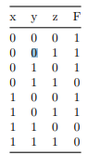

F = x’y’z’ + x’y’z + x’yz’ + xy’z’ + xy’z

4. Draw the combinational circuit that directly implements the following Boolean expression:

F(x,y,z) = y’ + xy + y’z.

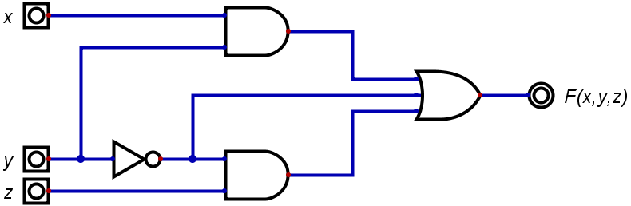

5. Consider the parity generator (even parity) shown in the truth table below. The parity bit Y is a function of Boolean variables A, B, and C. Represent this parity function in the following ways:

1. As a Boolean algebraic expression.

A’B’C + A’BC’ + AB’C’ + ABC

2. As a combinational logic diagram (logic circuit).

